How to set APN?

1.Enter the router backend management interface, enter the IP address of the router through the browser: tendawifi.com, and then press the Enter key.
2.Log in with the administrator username and password.
3. Find the "Internet Settings" option and click to enter.
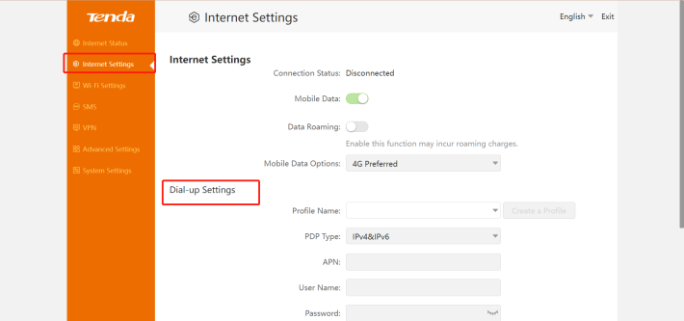
4.In the Dial-up Settings, enter the correct APN information provided by the operator and save the settings

