How to determine signal strength?

Our router provides an indication of signal strength on the interface. Log in to the router backend management interface and the 4G signal strength icon for the current connection will be displayed.
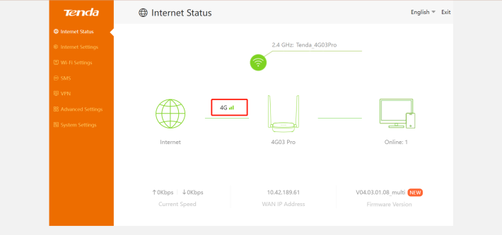

In addition, you can check the 4G signal light indication of the router. Usually, all three lights are on to indicate a strong signal, and one light is on to indicate a weak signal.

