How to upgrade the APN of 5G NR Router
When the 5G NR router is upgraded to the latest version, if there still problems such as unable to dial-up or failed to connect to the carrier network, you can check the current APN version of the 5G NR router and compare with the APN version on the official website, if it is not the latest version, you can download the latest APN file from the official website and follow the steps below to upgrade APN.
Check APN information
- Log in the web interface.
- Go to Advanced Settings > ISP Update.
- Check Current Version where shows the APN informatiom.
Update APN
1、Download the latest APN file for the router from our website https://www.tendacn.com/product/download/5G03.html
2、Log in the web interface.
- Go to Advanced Settings > ISP Update.
- Click Selectafile to locate the downloaded new APN file, and click Upgrade.

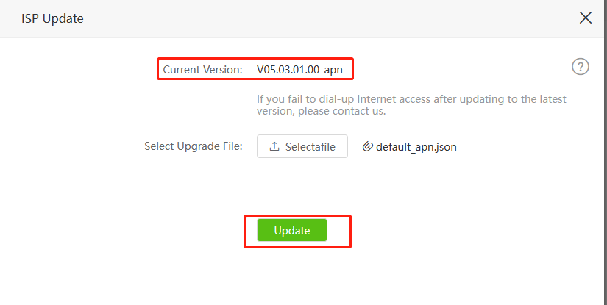

6、Wait a few seconds for there shows "Configuration succeeded." and no need to reboot the router.
Note: Only the software version number is higher than V05.03.01.08_ multi supports ISP Update.
After you do the above troubleshooting, if still no internet access, you will need to contact Tenda support to further troubleshoot your concern. You can contact support.fwa@tenda.cn

