Tenda 4G 180/185: How to save power of 4G LTE Mobile Wi-Fi via Phone web management interface (new logo)

Currently, the 4G180/4G185 latest hardware version is with 2100 mAh battery. However, the actual battery time may vary due to different user environments, so some customers might feel that the battery drains quite fast and even think the battery is defective. Actually, the battery life is affected by the power consumption, larger power consumption, and shorter battery life. The power consumption will increase in the following conditions:

1) Poor LTE signal
Please check the network type and signal strength, if the signal is quite weak, please try to move it to somewhere else with a good 4G signal.
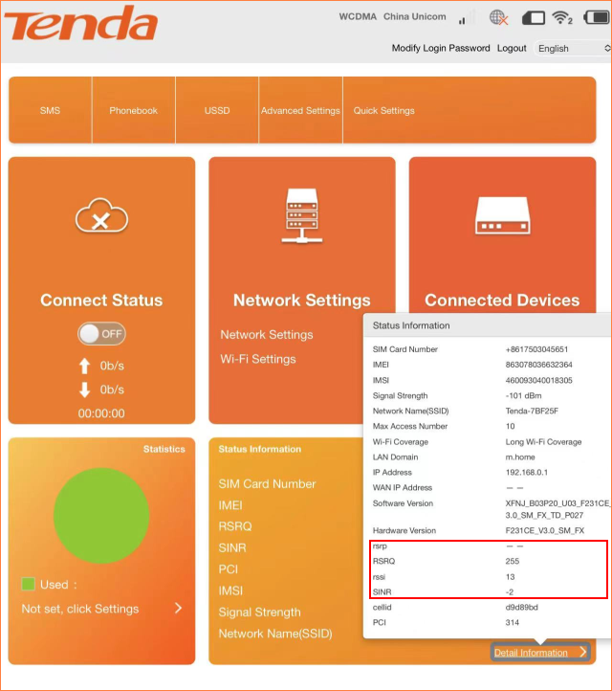

2）Too many clients are using the internet at the same time or some clients are using high-traffic operations such as large file downloading, streaming or gaming, etc.
Try to disconnect some client devices, and test again when client devices are only browsing the internet normally.
In addition, please enter Power-save settings, try to change W-iFi Coverage to “Short Wi-Fi Coverage - Best battery life” to save the power.Finally tap Apply.
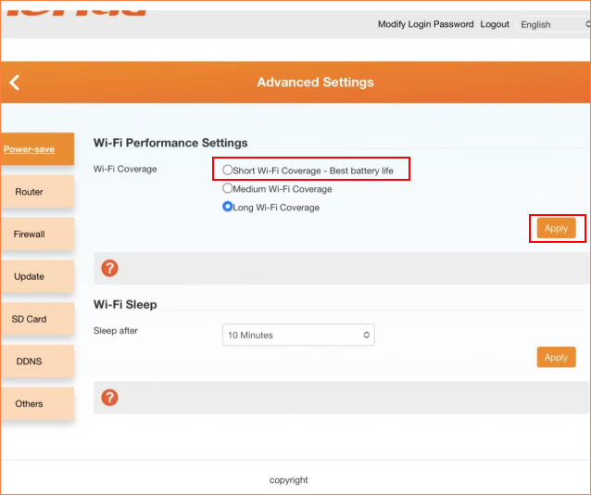

If there is still any problem, please contact Tenda Technical Support and provide detailed information:
1. Model number, hardware version, and firmware version
2. Describe the issue in detail, location, and carrier name
3. Network Type and Signal Strength, SIM supported bands
4. Whether and W-iFi Coverage has been changed to “Short Wi-Fi Coverage - Best battery life”
5. When the device was purchased and when the problem started happening
6. SpeedTest results when connected to the Mobile Wi-Fi via USB connection and Wi-Fi
7.In order to prolong battery life, it is recommended that you use a low-power charging head for charging, and turn off the charging in time after it is fully charged
8.We will replace the battery free of charge within the warranty period after confirming that the problem is due to the quality of the battery

To get to know more details about each function and configuration please go to Services>Service Provider>Download to download the manual of your product.

