Tenda 4G 180/185:How to save power of 4G LTE Mobile Wi-Fi via Phone web management interface

You can reduce the Wi-Fi range to save power. Alternatively, you can enable the Wi-Fi Sleep feature to disable the Wi-Fi of your Mobile Wi-Fi in the idling period.

Follow the steps below, here takes 4G185 as demonstration:
1.Log in the management interface of 4G LTE Mobile Wi-Fi
2. Go to Advanced Settings> Power-Save

To set Wi-Fi Range:
1.Select Long Wi-Fi Coverage, Medium Wi-Fi Coverage or Short Wi-Fi Coverage from the Wi-Fi Coverage list.

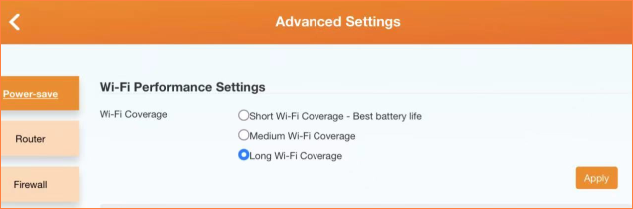

Note: The shorter the Wi-Fi Range is, the less power your Mobile Wi-Fi uses.
3. Tap Apply
4. Tap Yes to restart Wi-Fi on the pop-up to make the configurations take effect, and then reconnect to the Mobile Wi-Fi after the Wi-Fi restarts.

To set Wi-Fi Sleep
1.Tap the Sleep time button
2.Select sleep time from the drop-down list.

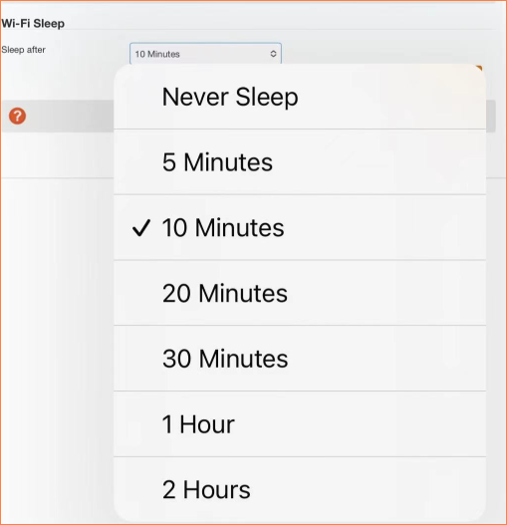

3. Tap Apply. If there are no devices connected to the Mobile Wi-Fi during the period you have specified, the Wi-Fi will be disabled automatically.

Note: To recover the Wi-Fi, press the Power Button or the Menu Button.

If there is still any problem, please contact Tenda Technical Support and provide detailed information:
1. Model number, hardware version, and firmware version
2. Describe the issue in detail, location, and carrier name
3. Network Type and Signal Strength, SIM supported bands
4. Whether and W-iFi Coverage has been changed to “Short Wi-Fi Coverage - Best battery life”
5. When the device was purchased and when the problem started happening
6. SpeedTest results when connected to the Mobile Wi-Fi via USB connection and Wi-Fi
7.In order to prolong battery life, it is recommended that you use a low-power charging head for charging, and turn off the charging in time after it is fully charged
8.We will replace the battery free of charge within the warranty period after confirming that the problem is due to the quality of the battery

To get to know more details about each function and configuration please go to ​Services>Service Provider>Download to download the manual of your product.

